Safety evaluation of ethanolic Morus alba leaf extract as a potential therapeutic agent for metabolic syndrome: A 28-day subacute toxicity study in rats

Mirnawati Salampe^{1*}, Sukamto S. Mamada², Imrawati³, Akbar Awaluddin¹, Ariansyah¹, Putri Amanda Dewi⁴, Agustina Putri Landa⁴, Anggi Nurdiniawati Saputri⁴, Inggrid Yolendari⁴, Dewiyanti Rumengan⁴

¹Department of Pharmacology and Clinical Pharmacy, Faculty of Health Sciences, Universitas Almarisah Madani, Makassar, 90245, Indonesia
²Department of Pharmacy, Faculty of Pharmacy, Hasanuddin University, Makassar, Indonesia
³Department of Pharmaceutical Chemistry, Faculty of Health Sciences, Universitas Almarisah Madani, Makassar, 90245, Indonesia
⁴Faculty of Health Sciences, Universitas Almarisah Madani, Makassar, 90245, Indonesia

*Corresponding author: mirnachamto@gmail.com

ABSTRACT

Morus alba leaf extract exhibits diverse pharmacological activities, highlighting its potential as a therapeutic agent for metabolic syndrome. However, data on the sub-acute toxicity of its ethanolic preparation remain limited. This study aimed to evaluate the 28-day oral toxicity of ethanolic M. alba leaf extract (EEM) based on hematological and biochemical parameters. Adult Wistar rats were divided into three groups, each consisting of five males and five females. Group I served as the normal control, groups II and III received the extract at doses of 200 and 400 mg/kg body weight, respectively, for 28 consecutive days. Body weight was monitored weekly. At the end of the treatment period, blood samples were collected for hematological and biochemical analyses. Subsequently, the animals were euthanized, and liver and kidney tissues were collected for histopathological examination. No mortality or overt signs of toxicity were observed in either sex. In male rats, erythrocyte, leukocyte, and platelet counts were comparable across all groups. In female rats, leukocyte and platelet counts were similar among groups, although minor variations in erythrocyte parameters were noted. Urea, creatinine, AST, and ALT levels showed no significant differences between treated and control groups in either sex. Histopathological examination revealed mild hepatocellular hydropic degeneration at 200 mg/kg BW and moderate hepatic alterations, including fatty degeneration, necrosis, and inflammatory cell infiltration, at 400 mg/kg BW. Kidney histology remained normal at 200 mg/kg BW, whereas mild renal edema was observed at 400 mg/kg BW. Overall, EEM was generally well tolerated; however, the histopathological findings at higher doses suggest the need for caution and further safety evaluation before its development as a therapeutic candidate for metabolic syndrome.
Keywords: kidney function; liver function; metabolic syndrome; Morus alba; subacute toxicity; hematological parameters

- INTRODUCTION
Metabolic syndrome (MetS) is a multifaceted condition characterized by insulin resistance, central obesity, dyslipidemia, and elevated blood glucose levels, all of which substantially increase the risk of cardiovascular disease (CVD) and type 2 diabetes mellitus (T2DM) and contribute to a considerable economic burden on healthcare systems (Obeidat et al., 2025). Its global prevalence, reported to range from 14% to 39% across countries, continues to rise, driven largely by widespread adoption of Western-style diets and sedentary lifestyles. This growing burden is further influenced by variations in ethnicity, age, sex, geographic location, and the diagnostic criteria used to define MetS (Muvhulawa et al., 2024). Chronic diseases associated with MetS, such as diabetes, hypertension, and CVD, remain major public health challenges due to their high morbidity and mortality. Despite advancements in treatment, optimal management requires consistent adherence to medications, lifestyle modifications, and routine medical follow-ups. However, non-adherence remains a significant global issue, undermining therapeutic effectiveness, diminishing quality of life, and increasing the risk of complications (Religioni et al., 2025). These challenges have prompted growing interest in plant-derived bioactive compounds, which may provide multifunctional metabolic benefits while offering improved safety profiles compared to conventional therapies.
A variety of medicinal plants contain bioactive compounds that directly address the key abnormalities of metabolic syndrome. These compounds enhance insulin sensitivity to combat insulin resistance, activate AMP-activated protein kinase (AMPK) to improve dysregulated lipid and glucose metabolism, and support pancreatic β-cell function to maintain glycemic control (Li et al., 2025). Their strong antioxidant and anti-inflammatory activities also help mitigate the chronic oxidative stress and persistent low-grade inflammation that drive the progression of metabolic syndrome, offering a comprehensive therapeutic approach to its management (Altanam et al., 2025; Manful et al., 2025). Among these plants, Morus alba, which has long been used in traditional Asian medicine, has demonstrated a wide range of therapeutic benefits, including improving glucose metabolism, reducing inflammation, regulating lipid profiles, exerting anti-obesity and antihypertensive effects, offering cardioprotection, and modulating oxidative stress (Salampe et al., 2026; Chen et al., 2023; Porasar et al., 2025; Salampe et al., 2025; Suthamwong et al., 2020; Tricase et al., 2025; Trimarco et al., 2025; Batiha et al., 2023; El et al., 2023; Porasar et al., 2025). The leaves of Morus alba are rich in bioactive compounds, including flavonoids, alkaloids, and phenolic acids, which contribute to their pharmacological properties (Chen et al., 2023; Trimarco et al., 2025). These findings suggest that M. alba has potential as a complementary or alternative therapeutic agent for managing metabolic syndrome.
However, despite its widespread traditional use and growing scientific interest, safety data on the prolonged oral administration of Morus alba leaf extract, particularly ethanol-based preparations, remain limited. Most available studies have focused mainly on acute toxicity or short-term efficacy (Fauzi et al., 2024; Li et al., 2018; Nurita et al., 2018), leaving a significant knowledge gap regarding potential cumulative toxicity, organ-specific adverse effects, and possible hematological and biochemical disturbances that may arise from repeated exposure. Although a 28-day repeated-dose oral toxicity study using an aqueous extract of M. alba demonstrated excellent safety at doses up to 4,000 mg/kg body weight per day, with no treatment-related mortality, clinical abnormalities, or organ-specific toxicities observed in Wistar rats (Marx et al., 2016), these findings cannot be directly generalized to ethanol-based extracts. Given that solvent type significantly influences phytochemical composition and may alter toxicity profiles (Bouasla et al., 2021; Sun et al., 2025), evaluating the subacute toxicity of the ethanolic extract becomes essential. Such an assessment is crucial to ensure its safety for potential therapeutic use in managing metabolic syndrome.
Subacute toxicity studies, in which animals receive the test compound once daily for 28 consecutive days, are recommended by international guidelines such as OECD Test Guideline 407. In this study, the ethanolic Morus alba extract is administered orally at doses of 200 mg/kg BW and 400 mg/kg BW, selected based on its potential therapeutic effects on metabolic syndrome observed in previous pharmacological evaluations. When delivered by gavage, each dose is given as a single daily administration using a stomach tube or an appropriate intubation cannula. These studies are essential for assessing repeated-dose safety, identifying potential target-organ toxicity, and determining the no-observed-adverse-effect level (NOAEL). Hematological and biochemical parameters serve as sensitive indicators of systemic toxicity, providing early evidence of hepatic or renal impairment, metabolic disturbances, or bone marrow suppression (Guidelines, 2025). Such evaluations are especially important for compounds intended to manage metabolic syndrome, as they may require extended administration and act on pathways closely linked to liver, kidney, and hematological homeostasis.

2. MATERIALS AND METHODS
  - 2.1 Plant Material and Extraction
Morus alba leaves were collected from Wajo Regency, South Sulawesi, Indonesia. The dried powdered leaves were extracted using the maceration technique with 70% ethanol (Q.-W. Zhang et al., 2018). The powdered material was initially moistened and soaked in the solvent, then kept in a dark place at room temperature for 72 hours with occasional stirring. Following filtration, the remaining residue was subjected to a second maceration using the same solvent. The combined filtrates were concentrated using a rotary evaporator at 60 °C and 75 rpm to obtain a thick extract, which was subsequently frozen at −20 °C for about 24 hours before undergoing lyophilization through the freeze-drying process. This procedure was maintained for 24 hours to produce a dry extract. Freeze-drying was employed to maintain the integrity of bioactive constituents and to achieve a low moisture content (Coşkun et al., 2024), thereby enhancing the extract’s stability and shelf life.
2.2 Animal Preparation
Thirty healthy male Wistar rats (aged 2–3 months, weighing 150-180 g) were utilized in this study. The animals were obtained from the Faculty of Pharmacy, Hasanuddin University, Indonesia. During a one-week acclimatization period, they were housed under standard laboratory conditions with a 12-hour light/dark cycle and given free access to food and water. Only rats that maintained or gained body weight during this period were included. Ethical clearance for the experiment was approved by the Research Ethics Committee of Sekolah Tinggi Ilmu Farmasi under approval number 12.199/KOMETIK/STIFA/XII/2025.
2.3 Experimental Procedures
2.3.1 Sub-acute toxicological study
A sub-acute toxicity study was carried out using adult Wistar rats of both sexes. The animals were weighed and randomly allocated into three groups, each comprising 10 rats (5 males and 5 females). Group I served as the normal control, while Groups II and III received the leaf extract at doses of 200 and 400 mg/kg, respectively, for 28 consecutive days. Body weight was recorded weekly throughout the study. At the end of the experimental period, blood samples were collected via orbital venous sinus and cardiac puncture and immediately subjected to hematological and biochemical analyses.
2.3.2 Hematological analysis
The hematological parameters evaluated included erythrocytes, red blood cell (RBC) indices, total and differential white blood cell (WBC) counts and platelet count. All measurements were performed in the Clinical Pharmacy Laboratory, Faculty of Pharmacy, Hasanuddin University, using an automated hematology analyzer (Dymind DH36).
2.3.3 Biochemical analysis
2.3.3.1 Liver and kidney function test
Biochemical indices assessed for liver function included aspartate transaminase (AST) and alanine aminotransferase (ALT), while kidney function was evaluated by measuring serum creatinine and urea levels. All analyses were performed in the Clinical Pharmacy Laboratory, Faculty of Pharmacy, Hasanuddin University, using a Humalyzer 4000 analyzer with HUMAN diagnostic kits.

2.3.4 Histopathological Analysis
At the end of the experimental period, all rats were euthanized, and the liver and kidney tissues were harvested for histopathological examination. The collected organs were fixed in formalin and processed according to standard histological procedures, including dehydration through graded alcohol solutions, paraffin embedding, and sectioning into 5 µm-thick slices. The tissue sections were then stained with hematoxylin and eosin (H&E) and examined under a light microscope for the evaluation of histopathological alterations.
2.4 Statistical Analysis
Body weight changes, hematological, and biochemical data obtained from this study were analyzed using one-way ANOVA followed by Least Significant Difference (LSD) post hoc tests using SPSS version 24. Statistical significance was accepted at p < 0.05.

3. RESULTS
  - Body Weight Changes
During the 28-day administration of the ethanolic extract of Morus alba (EEM) in both female and male rats, no signs of toxicity or mortality were observed. Although all three female groups exhibited an overall upward trend in body-weight progression, variations were noted in the percentage of weight change. The normal control females showed a 23.5% increase over the 28-day period, whereas the EEM 400 mg/kg BW group gained 12.5%, and the EEM 200 mg/kg BW group demonstrated a smaller increase of 7.6%. Conversely, among the male groups, both the normal control and the EEM 400 mg/kg BW groups displayed relatively comparable weight increases of approximately 38% and 30%, respectively. In contrast, the EEM 200 mg/kg BW group showed a more modest rise of around 10%, which was significantly lower than that observed in the other two male groups. The average body weights of female and male rats are depicted in Figure 1.

  - Hematological Analysis
Hematological analyses were conducted to evaluate potential changes in blood parameters following EEM administration, using blood samples from both male and female rats. Overall, there were no significant differences in WBC and platelet parameters at any dose compared with the control groups, as shown in Tables 1 and 2. Erythrocyte parameters in male rats also remained comparable across all groups. However, only the erythrocyte parameters of female rats showed some significant differences between treatment groups.

A
B

Figure 1. The average body weight of (A) female and (B) male Wistar rats administered the ethanolic extract of Morus alba leaves throughout the 28-day toxicity evaluation. EEMF: ethanolic extract of Morus alba leaves in female rats; EEMM: ethanolic extract of Morus alba leaves in male rats.

Table 1. Blood counts in female rats at the end of 28 days of treatment.

PARAMETER | NORMAL CONTROL | EEM 200 mg/kg BW | EEM 400 mg/kg BW
Erythrocytes (10⁶/µL) | 6.75 ± 0.31 | 7.32 ± 0.40 | 7.37 ± 0.54
Hemoglobin (g/dL) | 16.32 ± 0.90 ^{(a)} | 17.80 ± 0.82 ^{(b)} | 17.06 ± 0.61 ^{(a,b)}
Hematocrit (%) | 41.08 ± 1.14 ^{(a)} | 44.58 ± 1.93 ^{(b)} | 44.34 ± 2.49 ^{(b)}
MCV (fL) | 60.88 ± 1.54 | 60.92 ± 1.42 | 60.20 ± 2.17
MCH (pg) | 24.18 ± 0.49 | 24.32 ± 1.45 | 23.24 ± 1.28
MCHC (g/dL) | 39.72 ± 1.39 | 39.94 ± 1.87 | 38.52 ± 1.03
RDW-CV (%) | 17.08 ± 1.31 | 15.00 ± 1.27 | 15.82 ± 1.04
RDW-SD (fL) | 35.06 ± 2.60 ^{(a)} | 30.80 ± 2.14 ^{(b)} | 31.94 ± 2.35 ^{(a,b)}
Mentzr | 9.04 ± 0.62 | 8.35 ± 0.62 | 8.21 ± 0.83
RDWI | 154.51 ± 14.58 ^{(a)} | 125.17 ± 11.76 ^{(b)} | 130.21 ± 16.51 ^{(b)}
WBC (10³/µL) | 21.52 ± 3.17 ^{(a)} | 14.54 ± 2.15 ^{(b)} | 15.13 ± 5.90 ^{(b)}
Lym% | 94.76 ± 1.67 | 93.96 ± 4.25 | 92.88 ±2.54
Gran% | 1.14 ± 0.42 | 1.56 ± 1.28 | 1.72 ± 0.80
Mid% | 4.10 ± 1.40 | 4.48 ± 2.97 | 5.40 ± 1.75
Lym (10⁹/L) | 20.38 ± 2.85 | 13.63 ± 1.95 | 14.02 ± 5.32
Gran (10⁹/L) | 0.25 ± 0.10 | 0.24 ± 0.21 | 0.27 ± 0.19
Mid (10⁹/L) | 0.90 ± 0.37 | 0.67 ± 0.48 | 0.84 ± 0.47
PLT (10³/µL) | 1260.20 ± 245.70 | 1123.60 ± 112.93 | 1065.60 ± 99.80
MPV (fL) | 7.32 ± 0.33 | 7.58 ± 0.52 | 7.34 ± 0.39
PDW (%) | 7.84 ± 0.39 | 7.66 ± 0.97 | 8.10 ± 0.45
PCT (%) | 0.93 ± 0.20 | 0.85 ± 0.12 | 0.78 ± 0.08
P-LCR (%) | 12.32 ± 2.58 | 15.02 ± 3.78 | 11.92 ± 2.44
P-LCC (10³/µL) | 158.20 ± 50.92 | 170.40 ± 51.50 | 126.80 ± 30.43

Note: a and b indicate significance between groups. Identical letters denote no significant difference, while different letters indicate a significant difference (p < 0.05). Data are expressed as the means ± SD of five animals in each group.

Table 2. Blood counts in male rats at the end of 28 days of treatment.

PARAMETER | NORMAL CONTROL | EEM 200 mg/kg BW | EEM 400 mg/kg BW
Erythrocytes (10⁶/µL) | 7.80 ± 1.17 | 7.81 ± 0.84 | 8.41 ± 0.54
Hemoglobin (g/dL) | 17.34 ± 2.42 | 17.90 ± 1.70 | 18.98 ± 0.61
Hematocrit (%) | 45.62 ± 7.29 | 45.80 ± 4.03 | 49.94 ± 2.49
MCV (fL) | 58.48 ± 1.15 | 58.78 ± 2.03 | 59.40 ± 2.17
MCH (pg) | 22.30 ± 0.39 | 23.00 ± 0.98 | 22.62 ± 1.28
MCHC (g/dL) | 38.14 ± 1.22 | 39.12 ± 0.65 | 38.10 ± 1.03
RDW-CV (%) | 17.68 ± 1.37 | 18.42 ± 1.31 | 17.14 ± 1.04
RDW-SD (fL) | 34.58 ± 2.30 | 36.22 ± 2.34 | 33.96 ± 2.35
Mentzr | 7.65 ± 1.25 | 7.62 ± 1.16 | 7.12 ± 0.83
RDWI | 134.69 ± 18.81 | 139.49 ± 16.09 | 121.88 ± 16.51
WBC (10³/µL) | 15.53 ± 4.35 | 18.64 ± 5.12 | 14.94 ± 5.90
Lym% | 93.96 ± 3.11 | 89.82 ± 11.47 | 94.34 ± 2.54
Gran% | 1.44 ± 0.94 | 3.34 ± 4.65 | 1.58 ± 0.80
Mid% | 4.60 ± 2.19 | 6.84 ± 6.86 | 4.08 ± 1.75
Lym (10⁹/L) | 14.53 ± 3.91 | 16.33 ± 2.78 | 14.12 ± 5.32
Gran (10⁹/L) | 0.24 ± 0.18 | 0.78 ± 1.25 | 0.23 ± 0.19
Mid (10⁹/L) | 0.75 ± 0.46 | 1.52 ± 1.88 | 0.59 ± 0.47
PLT (10³/µL) | 847.20 ± 257.22 | 1030.00 ± 102.41 | 968.00 ± 99.80
MPV (fL) | 7.00 ± 0.23 | 6.98 ± 0.31 | 7.10 ± 0.39
PDW (%) | 7.94 ± 0.44 | 7.44 ± 0.92 | 7.92 ± 0.45
PCT (%) | 0.59 ± 0.18 | 0.72 ± 0.10 | 0.69 ± 0.08
P-LCR (%) | 9.44 ± 1.44 | 10.90 ± 1.81 | 10.70 ± 2.44
P-LCC (10³/µL) | 79.40 ± 28.07 | 113.20 ± 28.27 | 103.20 ± 30.43

Data are expressed as the means ± SD of five animals in each group.

Serum Biochemical Analysis
Repeated oral administration of EEM for 28 days did not produce any statistically significant changes in urea, AST, or ALT levels compared with the normal control groups in both male and female rats (Tables 3 and 4). The creatinine levels of male rats treated with EEM were also comparable to those of the normal control group. However, in female rats, a statistically significant difference (p < 0.05) in creatinine levels was observed—specifically between the normal control group and the EEM 200 mg/kg BW group, as well as between the 200 mg/kg BW and 400 mg/kg BW groups.
Table 3. Biochemical parameters in female rats at the end of 28 days of treatment.

PARAMETER | NORMAL CONTROL | EEM 200 mg/kg BW | EEM 400 mg/kg BW
CREATININE (mg/dL) | 1.70 ± 0.26 ^{(a)} | 1.15 ± 0.18 ^{(b)} | 1.58 ± 0.11 ^{(a)}
UREA (mg/dL) | 33.58 ± 3.18 | 47.63 ± 8.70 | 39.24 ± 12.71
AST (U/L) | 225.80 ± 76.42 | 199.20 ± 38.17 | 217.75 ± 7.72
ALT (U/L) | 61.00 ± 13.71 | 47.00 ± 8.34 | 68.20 ± 15.94

Note: a and b indicate significance between groups. Identical letters denote no significant difference, while different letters indicate a significant difference (p < 0.05). Data are expressed as the means ± SD of five animals in each group.

Table 4. Biochemical parameters in male rats at the end of 28 days of treatment.

PARAMETER | NORMAL CONTROL | EEM 200 mg/kg BW | EEM 400 mg/kg BW
CREATININE (mg/dL) | 1.39 ± 0.45 | 1.40 ± 0.15 | 1.32 ± 0.13
UREA (mg/dL) | 40.06 ± 4.88 | 40.06 ± 11.37 | 44.40 ± 11.66
AST (U/L) | 205.20 ± 9.63 | 264.20 ± 39.44 | 215.60 ± 7.72
ALT (U/L) | 65.00 ± 15.41 | 67.00 ± 14.95 | 62.80 ± 15.94

Data are expressed as the means ± SD of five animals in each group.

  - Histopathological Analysis
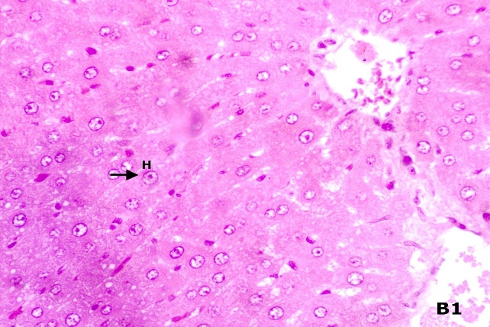
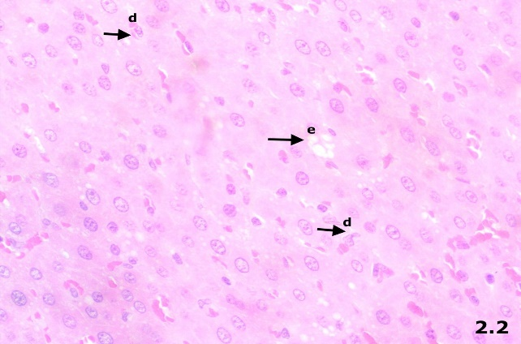
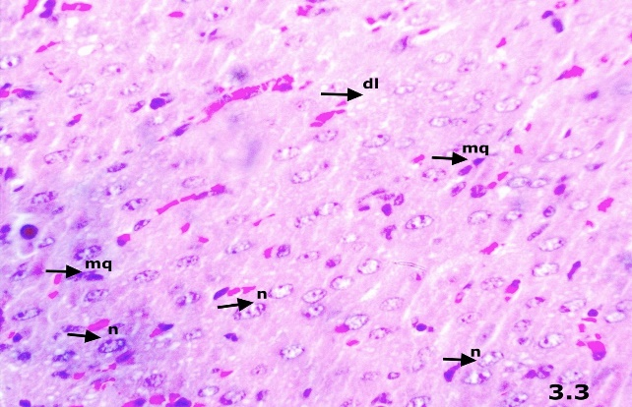
After 28 consecutive days of EEM administration, histopathological examinations of the liver and kidneys were performed in both female and male rats. Microscopic evaluation of liver sections revealed mild hydropic degeneration of hepatocytes in both sexes following treatment with EEM at a dose of 200 mg/kg body weight. In contrast, administration of EEM at 400 mg/kg body weight resulted in moderate hepatic alterations in both female and male rats, characterized by moderate fatty degeneration, moderate hepatocellular necrosis, and moderate inflammatory cell infiltration.
A
B
C

Figure 2. Effects of EEM on liver histology in female rats following 28 days of treatment (Hematoxylin and Eosin staining, 40× magnification). A: Normal liver histology of the control female rat showing intact hepatocytes. B: Female rats treated with EEM at 200 mg/kg body weight exhibited mild edema (e) and mild cellular degeneration (d). C: Female rats treated with EEM at 400 mg/kg body weight showed moderate hepatic alterations, including moderate necrosis (n), increased macrophage infiltration (mq), and moderate fatty degeneration (dl). Abbreviations: e, edema; d, cellular degeneration; n, necrosis; mq, macrophage infiltration; dl, fatty degeneration.
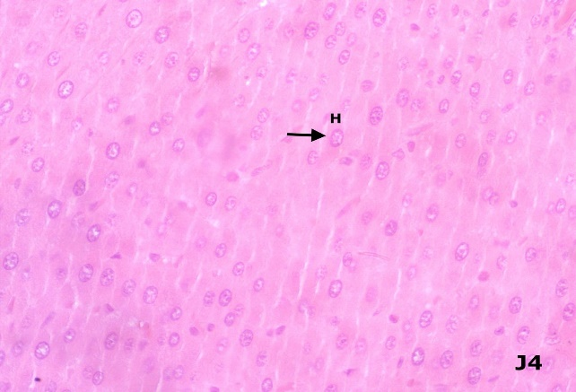
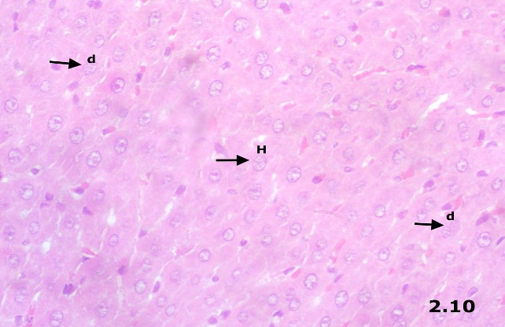
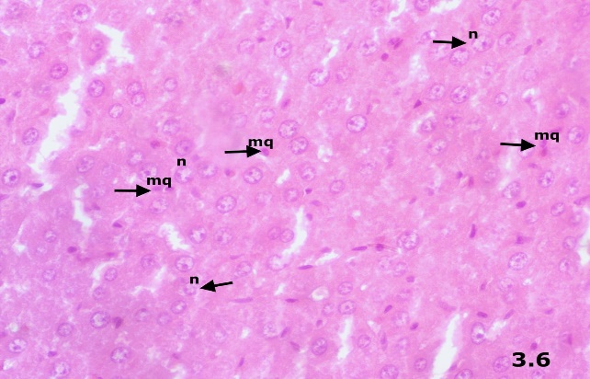
A
B
C

Figure 3. Effects of EEM on liver histology in male rats following 28 days of treatment (Hematoxylin and Eosin staining, 40× magnification). A: Normal liver histology of the control male rat showing intact hepatocytes. B: male rats treated with EEM at 200 mg/kg body weight exhibited mild cellular degeneration (d). C: male rats treated with EEM at 400 mg/kg body weight showed moderate hepatic alterations, including moderate necrosis (n), and increased macrophage infiltration (mq). Abbreviations: e, edema; d, cellular degeneration; n, necrosis; mq, macrophage infiltration; h, hepatocytes.
Histopathological analysis of kidney tissues demonstrated normal renal morphology in both female and male rats treated with EEM at a dose of 200 mg/kg body weight, with intact glomeruli and renal tubules and no evidence of pathological alterations. However, administration of EEM at 400 mg/kg body weight resulted in mild renal edema.

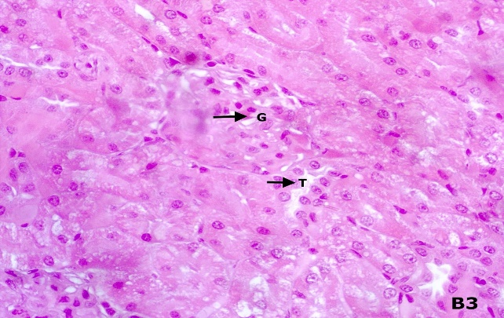
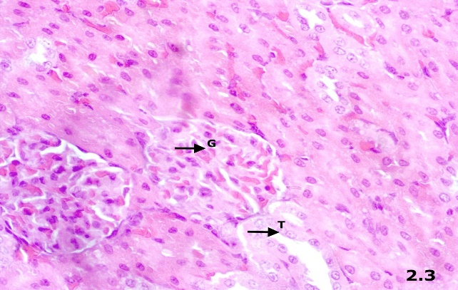
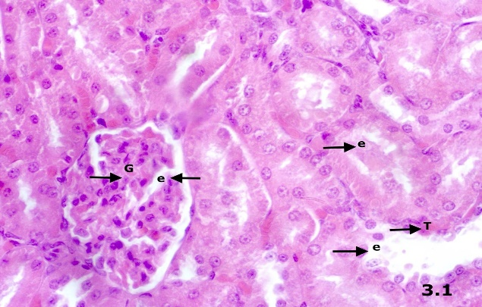
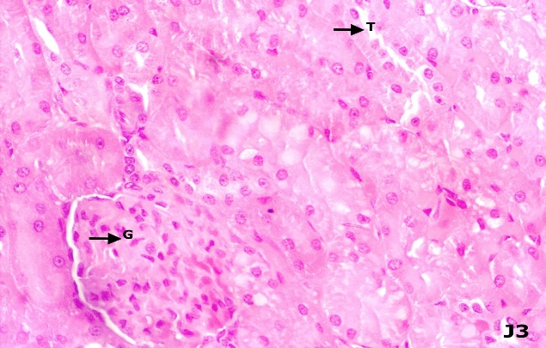
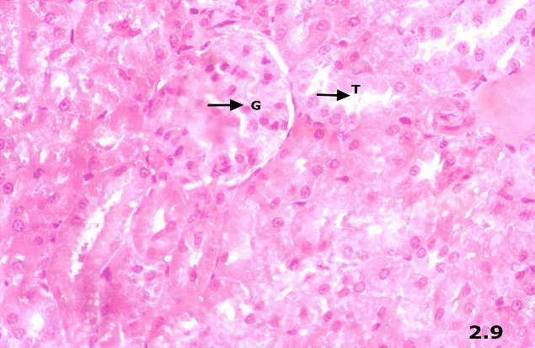
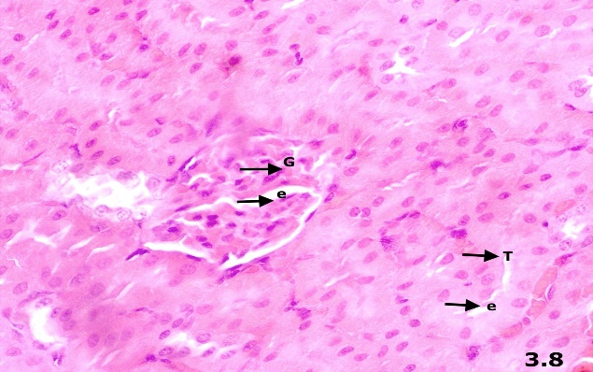
A
B
C
D
E
F

Figure 5. Effects of EEM on Kidney histology in female (A-C) and male (D-F) rats following 28 days of treatment (Hematoxylin and Eosin staining, 40× magnification). A&D: Normal renal histology of the control rats showing intact glomeruli and renal tubules. B&E: Rats treated with EEM at 200 mg/kg body weight showed no observable changes in glomerular or tubular structures. C&F: Rats treated with EEM at 400 mg/kg body weight exhibited mild edema. Abbreviations: G, glomerulus; T, renal tubule; e, edema.

4. DISCUSSION
During the 28-day administration of the ethanolic extract of Morus alba (EEM), no signs of toxicity or mortality were recorded in either female or male rats. Body weight should be measured in toxicological studies in rats because it is a sensitive indicator of systemic toxicity, metabolic stress, or reduced feed intake, and significant changes, such as a maximum 10% loss in one week, can signal adverse effects at the tested dose (Chapman et al., 2013; Marxfeld et al., 2019; Taylor-lapole et al., 2022).

In this study, all groups demonstrated an overall steady rise in body weight; however, the magnitude of weight gain differed between sexes and dosing groups. Female rats in the normal control group showed the highest increase (23.5%), while the EEM 400 mg/kg BW and 200 mg/kg BW groups gained 12.5% and 7.6%, respectively. In male rats, the normal control and EEM 400 mg/kg BW groups exhibited substantial increases of 38% and 30%, whereas the EEM 200 mg/kg BW group had a more modest rise of approximately 10%. Although variations occurred, all changes remained within normal physiological ranges for healthy growing rats.

These findings align well with earlier acute-toxicity studies. In a 14-day observation following a single 2,000 mg/kg dose of Morus alba extract, no significant differences in body weight were found between treated and control mice (Fauzi, Kifli, et al., 2024). Similarly, rats administered a standardized Morus alba extract at doses up to 4,000 mg/kg/day showed no mortality, abnormal behaviour, or disturbances in weight gain (Marx et al., 2016). Altogether, these consistent results reinforce the safety of Morus alba extracts, suggesting an LD₅₀ above 2,000 mg/kg and providing strong evidence that the extract does not produce harmful effects even with repeated exposure (Li et al., 2018; Nurita et al., 2018).

Hematological evaluation is crucial in toxicology because toxicants can directly affect the blood and related organs, producing measurable abnormalities (Arika et al., 2016). In this study, erythrocyte, leukocyte, and platelet counts in male rats were comparable across all experimental groups. Similarly, in female rats, differential leukocyte counts and platelet counts did not differ among groups, although slight variations in erythrocyte counts were observed. In the female groups, WBC levels were highest in the normal control group, whereas both EEM-treated groups exhibited noticeably lower but comparable values. Nevertheless, previous studies have reported leukocyte counts of approximately 21,000 cells/µL in normal rats (Sood et al., 2024).

Based on the findings, the EEM-treated groups did not show toxic effects on total WBC counts or differential leukocyte profiles. Although WBC counts in the two EEM-treated groups were significantly lower than those in the normal group, other studies have demonstrated that normal WBC counts in rats typically range from 2,000 to 10,000 cells/µL (Rahmawati et al., 2022). Variations in normal WBC values may be influenced by rat strain differences and variability among breeders or suppliers; therefore, reference intervals should be verified when sourcing animals from new suppliers to avoid data misinterpretation (Kampfmann et al., 2012).

Furthermore, hemoglobin levels in the normal and EEM-treated female groups showed a significant difference (p < 0.05), with values ranging from approximately 16–17 g/dL. Nevertheless, previous studies have reported normal hemoglobin levels of around 13 g/dL (Chinenye et al., 2019; Sood et al., 2024). Additionally, statistically significant differences were observed in hematocrit (HCT), RDW-SD, and RDWI between the normal and EEM-treated female groups; however, all measured values remained within physiologically acceptable ranges. These findings are consistent with previous reports indicating that hematological parameters vary with age and sex. In particular, HCT in female rats has been shown to increase progressively up to 12 months of age, reaching approximately 40–42% between 3 and 12 months. Supporting this observation, earlier studies have demonstrated age-related changes in hematological indices in healthy male and female rats, with red blood cell counts increasing with advancing age and sex-related differences becoming more pronounced from 12 months onward, while remaining within established reference ranges (Filho et al., 2018).

Renal function was assessed in this study using serum creatinine and urea, which serve as indicators of glomerular filtration and overall kidney health. Creatinine, a breakdown product of creatine phosphate in muscle, is produced at a fairly constant rate depending on muscle mass and is widely used to assess kidney function. The creatinine clearance test is employed to monitor the progression of renal disease, and renal failure is usually suspected when serum creatinine exceeds the upper limit of the normal range. Urea, the primary nitrogenous end product of protein and amino acid metabolism, is produced by the liver and distributed throughout body fluids. In the kidneys, urea is filtered by the glomeruli and partially reabsorbed with water. Serum urea concentration is a commonly used clinical marker for evaluating renal function (Ávila et al., 2025; Gowda et al., 2010; Inker & Titan, 2021).

In both female and male rats, urea levels were slightly elevated in the EEM-treated groups; however, these differences were not statistically significant compared to the control. Similarly, creatinine levels in male rats were slightly higher in the EEM 200 mg/kg BW group, yet no significant differences were observed among all groups. This observation is consistent with previous studies reporting the renoprotective effects of Morus alba extract, which has been shown to maintain normal kidney function and improve renal biomarkers, including serum urea and creatinine levels (Dkhil et al., 2015; Fauzi, Titisari, et al., 2024; Nguyen et al., 2025).

Other parameters assessed in this study were aminotransferases, including AST and ALT, which serve as key markers of liver injury. These enzymes facilitate gluconeogenesis by transferring amino groups from aspartic acid or alanine to α-ketoglutaric acid, producing oxaloacetic acid and pyruvic acid, respectively. AST is present in both the cytosol and mitochondria across multiple tissues, including the liver, heart, skeletal muscle, kidneys, and brain, but it is less liver-specific than ALT. In contrast, ALT is mainly cytosolic and concentrated in the liver, with a half-life of approximately 47 hours, and its levels are usually higher than AST in liver diseases. Hepatocellular damage causes these enzymes to be released into the circulation, and their levels are generally higher in males and positively correlated with BMI (Altaihani et al., 2024).

The study showed that AST and ALT levels in EEM-treated rats, in both female and male groups, did not significantly change compared to the controls, suggesting that the extract did not induce enzyme leakage or disturbances in hepatic metabolism. Supporting this, a repeated 28-day administration of Mulberry powder at a dose of 1000 mg similarly did not alter AST or ALT levels, with no substantial differences observed between the treated and control groups (Marxfeld et al., 2019).

Furthermore, histopathological examination of liver tissues revealed mild cellular degeneration and edema in hepatocytes of both male and female rats treated with EEM at 200 mg/kg body weight. However, exposure to EEM at 400 mg/kg body weight induced more pronounced hepatic changes, including moderate fatty degeneration, hepatocellular necrosis, and macrophage cell infiltration in both sexes. Renal histology remained largely unaffected in both sexes following treatment with EEM at 200 mg/kg body weight, with preservation of normal glomerular and tubular structures and no apparent histopathological abnormalities. However, administration of the higher dose (400 mg/kg body weight) was associated with the development of mild renal edema.

Although EEM administration did not significantly alter body weight, hematological parameters, or biochemical markers, histopathological examination revealed microscopic changes in the liver and kidney tissues, particularly at the dose of 400 mg/kg body weight. The observed hepatocellular degeneration, fatty changes, necrosis, and macrophage infiltration suggest that prolonged exposure to phytochemical constituents in the extract may have induced an adaptive or toxic response in the liver. As the primary organ responsible for xenobiotic metabolism, the liver is particularly vulnerable to injury following repeated administration of high doses of EEM, which may increase the metabolic burden on hepatocytes and promote cellular damage and inflammation (Y. Zhang et al., 2022). These findings may be associated with herbal-induced liver injury (HILI), a multifactorial process involving both direct hepatocellular toxicity and immune-mediated mechanisms (Łupina et al., 2025). Herbal compounds or their metabolites can generate reactive species that induce oxidative stress, impair mitochondrial function, deplete antioxidant defences, and ultimately lead to hepatocyte apoptosis or necrosis. Furthermore, reactive metabolites may trigger immune responses that exacerbate liver injury, particularly in susceptible individuals (Liu et al., 2016; Łupina et al., 2025).
Similarly, the mild renal edema observed at 400 mg/kg body weight may indicate early renal stress. Although the exact mechanism of renal injury remains unclear, previous studies have reported that plants rich in triterpenoids may exhibit nephrotoxic effects despite their therapeutic benefits (Akpan et al., 2024). This finding is supported by a study on Scoparia dulcis, a triterpenoid-rich plant, which induced renal toxicity as shown by increased serum urea, creatinine, and uric acid levels, accompanied by histopathological changes in kidney tissues (Adebiyi et al., 2021).
The kidneys are particularly vulnerable to toxic injury because they play a major role in the elimination of xenobiotics and their metabolites. During this process, some compounds may accumulate in renal tubular cells, especially in the proximal tubules, increasing the risk of cellular damage (George et al., 2017). In addition, Morus alba contains high levels of flavonoids, which are known for their antioxidant and anti-inflammatory activities. After metabolism in the liver, these compounds enter the circulation and are eventually excreted through the kidneys. Although flavonoids generally protect tissues from oxidative stress, they may also act as prooxidants under certain conditions, particularly in the presence of redox-active metals such as iron and copper (Jomova et al., 2025). This prooxidant activity may contribute to oxidative damage and could partly explain the mild renal alterations observed in the present study.
The discrepancy between normal biochemical findings and histopathological alterations suggests that tissue-level changes may precede detectable functional impairment. These findings indicate that while EEM appears to be generally well tolerated at lower doses, higher doses may induce mild to moderate organ-specific histological alterations, warranting further investigation into its long-term safety profile and underlying mechanisms of toxicity.

5. Acknowledgements
The authors express their sincere appreciation to the Ministry of Higher Education, Science, and Technology for the financial support provided through the Fundamental Grant funding. The authors also extend their gratitude to Universitas Almarisah Madani for the institutional support throughout this research. Appreciation is further given to the research team and colleagues for their collaboration and valuable input during the study.

6. References
Adebiyi, O. A., Ameh, D. A., Onyike, E., & James, D. B. (2021). Hepatotoxic and Nephrotoxic Effect of Ethanol Leaf Extract of Scoparia Dulcis ( Linn ) in Wistar Rats. 2(4), 20–27.
Akpan, J. L., Wokota, P. N., Ohadoma, S. C., Onwudiwe, T. C., Okoroama, C. E., Iganga, O. N., Nwokike, M. O., & Akuodor, G. C. (2024). Evaluation of nephrotoxicity effects of the methanol leaf extract of A . angustifolia in Wistar rats. 13(3), 307–314.
Altaihani, R. A., Fahad, B., Alhazmi, S., Albagawi, M. G., Mohamad, N., Almuzaini, A., Al, F. A., Salem, A., & Almotlaq, O. (2024). Liver Function Tests : An Updated Review Article for Clinical Pathologists. 23(December), 1681–1691.
Altanam, S. Y., Darwish, N., & Bakillah, A. (2025). Exploring the Interplay of Antioxidants, Inflammation, and Oxidative Stress: Mechanisms, Therapeutic Potential, and Clinical Implications. Diseases (Basel, Switzerland), 13(9). https://doi.org/10.3390/diseases13090309
Arika, W., Dw, N., Mn, M., Mp, N., & Enm, N. (2016). Thromboembolic Diseases Hematological Markers of In Vivo Toxicity. 4(2), 4–10. https://doi.org/10.4172/2329-8790.1000236
Ávila, M., Mora Sánchez, M. G., Bernal Amador, A. S., & Paniagua, R. (2025). The Metabolism of Creatinine and Its Usefulness to Evaluate Kidney Function and Body Composition in Clinical Practice. Biomolecules, 15(1). https://doi.org/10.3390/biom15010041
Batiha, G. E.-S., Al-Snafi, A. E., Thuwaini, M. M., Teibo, J. O., Shaheen, H. M., Akomolafe, A. P., Teibo, T. K. A., Al-kuraishy, H. M., Al-Garbeeb, A. I., Alexiou, A., & Papadakis, M. (2023). Morus alba: a comprehensive phytochemical and pharmacological review. Naunyn-Schmiedeberg’s Archives of Pharmacology, 396(7), 1399–1413. https://doi.org/10.1007/s00210-023-02434-4
Bouasla, I., Hamel, T., Barour, C., Bouasla, A., Hachouf, M., Bouguerra, O. M., & Messarah, M. (2021). Evaluation of solvent influence on phytochemical content and antioxidant activities of two Algerian endemic taxa: Stachys marrubiifolia Viv. and Lamium flexuosum Ten. (Lamiaceae). European Journal of Integrative Medicine, 42, 101267. https://doi.org/https://doi.org/10.1016/j.eujim.2020.101267
Chapman, K., Sewell, F., Allais, L., Delongeas, J.-L., Donald, E., Festag, M., Kervyn, S., Ockert, D., Nogues, V., Palmer, H., Popovic, M., Roosen, W., Schoenmakers, A., Somers, K., Stark, C., Stei, P., & Robinson, S. (2013). A global pharmaceutical company initiative: An evidence-based approach to define the upper limit of body weight loss in short term toxicity studies. Regulatory Toxicology and Pharmacology, 67(1), 27–38. https://doi.org/https://doi.org/10.1016/j.yrtph.2013.04.003
Chen, S., Xi, M., Gao, F., Li, M., Dong, T., Geng, Z., Liu, C., Huang, F., Wang, J., Li, X., Wei, P., & Miao, F. (2023). Evaluation of mulberry leaves’ hypoglycemic properties and hypoglycemic mechanisms. Frontiers in Pharmacology, 14, 1045309. https://doi.org/10.3389/fphar.2023.1045309
Chinenye, O. V., Delesi, K. H., Eriarie, A. O., Ogaba, A. G., Biology, E., State, R., State, R., & State, R. (2019). GSC Biological and Pharmaceutical Sciences Haematological profile of albino rats exposed to polar leaf extracts of Portulaca. 07(01), 75–85.
Coşkun, N., Sarıtaş, S., Jaouhari, Y., Bordiga, M., & Karav, S. (2024). The Impact of Freeze Drying on Bioactivity and Physical Properties of Food Products. Applied Sciences, 14(20). https://doi.org/10.3390/app14209183
Dkhil, M. A., Bauomy, A. A., Diab, M. S. M., & Al-quraishy, S. (2015). The Antioxidant Effect of Morus alba Leaves Extract on Kidney , Testes , Spleen and Intestine of Mice. 47(2), 393–397.
El, G., Batiha, S., Esmail, A., Snafi, A., Thuwaini, M. M., Oluwafemi, J., & Hazem, T. (2023). Morus alba : a comprehensive phytochemical and pharmacological review. 1399–1413. https://doi.org/10.1007/s00210-023-02434-4
Fauzi, A., Kifli, N., Noor, M. H. M., Hamzah, H., & Azlan, A. (2024). Hematological, biochemical, and histopathological evaluation of the Morus alba L. leaf extract from Brunei Darussalam: Acute toxicity study in ICR mice. Open Veterinary Journal, 14(3), 750–758. https://doi.org/10.5455/OVJ.2024.v14.i3.1
Fauzi, A., Titisari, N., Noor, M., Mohd., H., Azlan, A., & Hamzah, H. (2024). Therapeutic effect of Morus alba leaf extract and chlorogenic acid on inhibiting the progression of kidney disease. Cogent Food & Agriculture, 10(1), 2301841. https://doi.org/10.1080/23311932.2024.2301841
Filho, W. J., Lima, C. C., Rodolfo, M., Paunksnis, R., Silva, A. A., Perilhão, M. S., Caldeira, M., Bocalini, D., Jacob, W., Lima, C. C., Rodolfo, M., Paunksnis, R., Silva, A. A., Perilhão, M. S., Caldeira, M., Bocalini, D., & Rodrigues, R. (2018). Reference database of hematological parameters for growing and aging rats. The Aging Male, 21(2), 145–148. https://doi.org/10.1080/13685538.2017.1350156
George, B., You, D., Joy, M. S., & Aleksunes, L. M. (2017). Xenobiotic transporters and kidney injury. Advanced Drug Delivery Reviews, 116, 73–91. https://doi.org/10.1016/j.addr.2017.01.005
Gowda, S., Desai, P. B., Kulkarni, S. S., Hull, V. V, Math, A. A. K., & Vernekar, S. N. (2010). Markers of renal function tests. North American Journal of Medical Sciences, 2(4), 170–173.
Guidelines, O. (2025). Test Guideline No . 407 Repeated Dose 28-day Oral Toxicity Study in Rodents OECD GUIDELINES FOR THE TESTING OF CHEMICALS Repeated Dose 28-Day Oral Toxicity Study in Rodents. 407.
Inker, L. A., & Titan, S. (2021). Measurement and Estimation of GFR for Use in Clinical Practice: Core Curriculum 2021. American Journal of Kidney Diseases, 78(5), 736–749. https://doi.org/10.1053/j.ajkd.2021.04.016
Jomova, K., Alomar, S. Y., Valko, R., Liska, J., Nepovimova, E., Kuca, K., & Valko, M. (2025). Flavonoids and their role in oxidative stress, inflammation, and human diseases. Chemico-Biological Interactions, 413, 111489. https://doi.org/https://doi.org/10.1016/j.cbi.2025.111489
Kampfmann, I., Bauer, N., Johannes, S., & Moritz, A. (2012). Differences in hematologic variables in rats of the same strain but different origin. Veterinary Clinical Pathology, 41(2), 228–234. https://doi.org/10.1111/j.1939-165X.2012.00427.x
Li, M., Ding, L., Cao, L., Zhang, Z., Li, X., Li, Z., Xia, Q., Yin, K., Song, S., Wang, Z., Du, H., Zhao, D., Li, X., & Wang, Z. (2025). Natural products targeting AMPK signaling pathway therapy, diabetes mellitus and its complications. Frontiers in Pharmacology, 16, 1534634. https://doi.org/10.3389/fphar.2025.1534634
Li, Y., Xiaopeng, Z., Liang, C., Hu, J., & Yu, Z. (2018). Safety evaluation of mulberry leaf extract: Acute, subacute toxicity and genotoxicity studies. Regulatory Toxicology and Pharmacology, 95, 220–226. https://doi.org/https://doi.org/10.1016/j.yrtph.2018.03.007
Liu, C., Fan, H., Li, Y., & Xiao, X. (2016). Research Advances on Hepatotoxicity of Herbal Medicines in China. BioMed Research International, 2016(1), 7150391. https://doi.org/https://doi.org/10.1155/2016/7150391
Łupina, K., Nowak, A., Jabłońska, A., Potaczek, A., Salacha, J., Ilkiewicz, Ł., Kalisz, A., & Janczura, J. (2025). Herb-Induced Liver Injury. Livers, 5(4). https://doi.org/10.3390/livers5040055
Manful, C. F., Fordjour, E., Ikumoinein, E., Abbey, Lord, & Thomas, R. (2025). Therapeutic Strategies Targeting Oxidative Stress and Inflammation: A Narrative Review. BioChem, 5(4). https://doi.org/10.3390/biochem5040035
Marx, T. K., Glávits, R., Endres, J. R., Palmer, P. A., Clewell, A. E., Murbach, T. S., Hirka, G., & Pasics, I. (2016). A 28-Day Repeated Dose Toxicological Study of an Aqueous Extract of Morus Alba L. International Journal of Toxicology, 35(6), 683–691. https://doi.org/10.1177/1091581816670597
Marxfeld, H. A., Küttler, K., Dammann, M., Gröters, S., & van Ravenzwaay, B. (2019). Body and organ weight data in 28-day toxicological studies in two mouse strains. Data in Brief, 27, 104632. https://doi.org/10.1016/j.dib.2019.104632
Muvhulawa, N., Dludla, P. V, Ndlovu, M., Ntamo, Y., Mayeye, A., Luphondo, N., Hlengwa, N., Basson, A. K., Mabhida, S. E., Hanser, S., Mazibuko-Mbeje, S. E., Nkambule, B. B., & Ndwandwe, D. (2024). Global trends in clinical trials and interventions for the metabolic syndrome: A comprehensive analysis of the WHO International Clinical Trials platform. Contemporary Clinical Trials Communications, 40, 101330. https://doi.org/https://doi.org/10.1016/j.conctc.2024.101330
Nguyen, N. K., Nguyen, H. T. T., Mai, T. P., Trinh, Q. V., Duong, N. T., Pham, P. X., & Pham, V. A. T. (2025). Protective effects of Morus alba Linn leaf extract on streptozotocin-induced diabetic nephropathy in mice model. Phytomedicine Plus, 5(3), 100819. https://doi.org/https://doi.org/10.1016/j.phyplu.2025.100819
Nurita, R., Vitriana, A., Sukmara, I. M., & Utami, N. (2018). Mulberry Leaves ( Morus alba ) for Diabetes Mellitus : Acute Toxicity Test in Male Wistar Rats Daun Murbei ( Morus alba ) untuk Diabetes Mellitus : Uji Toksisitas Akut pada Tikus Wistar Jantan. 1(1).
Obeidat, A. A., Ahmad, M. N., Ghabashi, M. A., Alazzeh, A. Y., Habib, S. M., Abu Al-Haijaa, D., & Azzeh, F. S. (2025). Developmental Trends of Metabolic Syndrome in the Past Two Decades: A Narrative Review. Journal of Clinical Medicine, 14(7). https://doi.org/10.3390/jcm14072402
Porasar, P., Gibo, R., Gogoi, B., Sharma, D., Bharadwaj, A., Gam, S., Hazarika, D., & Dutta, K. N. (2025). A Systematic review on the phytochemistry, isolated compounds, nutritional benefits, pharmacology and toxicology of the plant species Morus alba L. Discover Plants, 2(1), 7. https://doi.org/10.1007/s44372-024-00043-w
Rahmawati, N., Syukri, M., Darmawi, D., Zachreini, I., Zulfiani, U., Yusuf, M., & Idroes, R. (2022). Haematological Features of White Rats (Rattus norvegicus) Infected with S. pyogenes and Administered with Probiotics (Yogurt). TheScientificWorldJournal, 2022, 2899462. https://doi.org/10.1155/2022/2899462
Religioni, U., Barrios-Rodríguez, R., Requena, P., Borowska, M., & Ostrowski, J. (2025). Enhancing Therapy Adherence: Impact on Clinical Outcomes, Healthcare Costs, and Patient Quality of Life. Medicina (Kaunas, Lithuania), 61(1). https://doi.org/10.3390/medicina61010153
Salampe, M., Rahimah, S., Nur, S., Mamada, S. S., Biring, F. S., Keyzia, K., Matandung, F. N., Payung, D., Rahman, A. A., Wahyuddin, N., & Ivone P., V. (2025). Uji Aktivitas Antioksidan Ekstrak Daun Murbei (Morus alba) Menggunakan Metode BCB, CUPRAC, dan FRAP. Jurnal Mandala Pharmacon Indonesia, 11(1), 149–157. https://doi.org/10.35311/jmpi.v11i1.723
Salampe, M., Widiasri, D. A. D., Wahyuddin, N., Agus, R. R., Imrawati, I., Awaluddin, A., Wahyuni, W., & Awaluddin, A. (2026). Therapeutic Effects of Morus alba Leaf Extract on Fasting Blood Glucose and Pancreatic β-Cell Restoration in HFD–STZ-Induced Diabetic Rats. Jurnal Jamu Indonesia, 11(2), 111–118. https://doi.org/10.29244/jji.v11i2.452
Sood, P., Shri, R., Singh, V., Ahmad, S. F., & Attia, S. M. (2024). Acute oral toxicity and safety assessment of Morus alba L . ( Moraceae ) methanol fruit extract in mice. 36(3), 11–19. https://doi.org/10.15586/ijfs.v36i3.2578
Sun, S., Yu, Y., Jo, Y., Han, J. H., Xue, Y., Cho, M., Bae, S.-J., Ryu, D., Park, W., Ha, K.-T., & Zhuang, S. (2025). Impact of extraction techniques on phytochemical composition and bioactivity of natural product mixtures. Frontiers in Pharmacology, 16, 1615338. https://doi.org/10.3389/fphar.2025.1615338
Suthamwong, P., Minami, M., Okada, T., Shiwaku, N., Uesugi, M., Yokode, M., & Kamei, K. (2020). Administration of mulberry leaves maintains pancreatic β-cell mass in obese/type 2 diabetes mellitus mouse model. BMC Complementary Medicine and Therapies, 20(1), 136. https://doi.org/10.1186/s12906-020-02933-4
Taylor-lapole, A. M., Cunny, H. C., & Shockley, K. R. (2022). Statistical Analysis of Rodent Body Weight Data is Robust to Departures from Normality in Historical National Toxicology Program Studies Dated 1980-2013. 25(7), 1–12. https://doi.org/10.22186/jyi.25.5.1.1
Tricase, A. F., Cavalluzzi, M. M., Catalano, A., De Bellis, M., De Palma, A., Basile, G., Sinicropi, M. S., & Lentini, G. (2025). Insights into the Activities and Usefulness of Deoxynojirimycin and Morus alba: A Comprehensive Review. Molecules, 30(15). https://doi.org/10.3390/molecules30153213
Trimarco, V., Gallo, P., Ghazihosseini, S., Izzo, A., Rozza, P. I., Spinelli, A., Cristiano, S., De Rosa, C., Rozza, F., & Morisco, C. (2025). White Mulberry Plant Extracts in Cardiovascular Prevention: An Update. Nutrients, 17(14). https://doi.org/10.3390/nu17142262
Zhang, Q.-W., Lin, L.-G., & Ye, W.-C. (2018). Techniques for extraction and isolation of natural products: a comprehensive review. Chinese Medicine, 13, 20. https://doi.org/10.1186/s13020-018-0177-x
Zhang, Y., Qi, Y., Huang, S., Jiang, X., Xiao, W., Wang, L., Liu, Z., & Liu, S. (2022). Role of ER Stress in Xenobiotic-Induced Liver Diseases and Hepatotoxicity. Oxidative Medicine and Cellular Longevity, 2022, 4640161. https://doi.org/10.1155/2022/4640161

